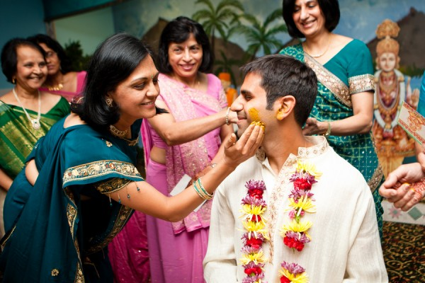

Haldi Ceremony Checklist
Indian Wedding Haldi Checklist

Known as Battne di Rasam in Punjabi Weddings, Gaye Haloud in Bengali Weddings and more commonly as just Haldi Ceremony, this traditon is an important South Asian Wedding custom to beautify and add wedding glow to the marrying couple. It is traditionally held in the respective homes of the bride and the groom, the day before the wedding.

In this ceremony, ubtan, or a natural skin rejuvenation peel, is applied on the arms, legs, and face of the bride and the groom. In essence it is a traditional South Asian Spa Treatment. The nourishing and anti-aging ingredients used in ubtan act as an exfoliant, cleanser, astringent, and skin tightener, which adds glow to the skin and enhances beauty. The ubtan peel once applied, is kept on for thirty minutes, and there after is scrubbed before taking the customary bath.

How to make Ubtan

Combine the following ingredients:
- 4 Tablespoons Chickpea Flour or besan
- 1 Tablespoon Turmeric or Haldi
- Couple Threads of Saffron

For dry skin:
- Add 1 Tablespoon of fresh milk cream, milk or yogurt

For oily skin:
- Add 1 Tablespoon of lemon juice

For fragarance add:
- 1 Teaspoon Sandalwood powder or Chandan
- 1 Teaspoon Rose water or Gulab Jal

Make a smooth, but thick paste with the help of mustard oil or water.

The Ceremony

In the actual ceremony, the bride/groom wear light clothes and sit on a stool, while they are surrounded by family and friends. Typically, the female relatives apply the ubtan to the bride/groom amidst celebration and singing of folk songs. During this ceremony, the bride/groom also give a portion of the paste to the unmarried friends/cousins. This is supposed to bring them a good looking husband/wife soon.

Haldi Ceremony Checklist

- Ubatan
- Short stool for bride/groom to sit
- Light traditional clothes which can be discarded after the ceremony
- Collection of Haldi Ceremony or Traditional Wedding Music
- Dholak (optional)
- A nice bowl for Ubtan
- Puja Thali or Plate decorated for the Haldi Ceremony

Tip for the bride/groom: Apply oil to your head right before haldi, so that ubtan does not stick to your head.

Sharing Policy
This document is meant for individual and non-commercial use only. All materials in this document, including the design, branding, and the written content are the intellectual property of Marigold Events.

It may be reproduced, remixed, retransmitted, distributed, published, broadcasted or circulated, including to individuals in the same company or organization, only with the express written consent of Marigold Events.

Please email neha@marigoldevents.com for more information. DO NOT USE THE CONTENT IN THIS DOCUMENT FOR COMMERCIAL USE, or verbatim which means you should not make money off of the content on this website, or copy the content.

