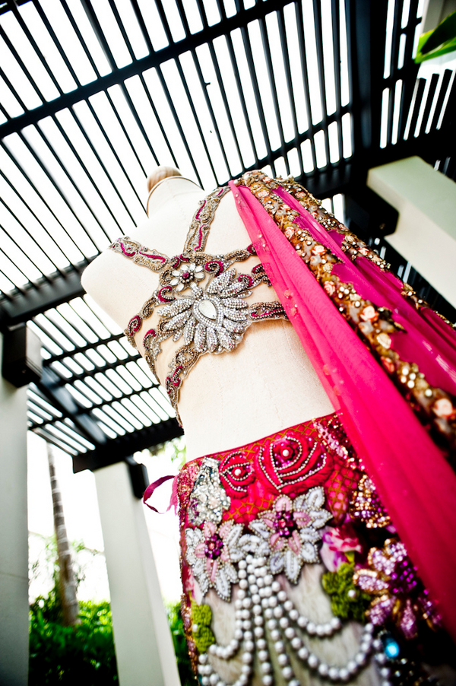
Indian Wedding Budget Worksheet

Indian Weddings are known to be elaborate affairs, where families spend a lot of money to entertain their guests and celebrate. No matter how big of an amount you are spending on the wedding, there is always a budget. So how do you come up with a budget for your wedding?

Start by compiling a list of finance sources, which could be you (the bride), the groom, both sets of parents, as well as other generous family members or friends.

In this worksheet, we will go through all the steps to decide how to plan your wedding budget. So start with coming up with a realistic figure.

Enter total budget: ________________

Once you have a realistic figure for your budget, we will divide that amount into various categories and what those categories should include.

Ceremony: 5%
- Cost of the venue
- All transportation like horse carriage for Baraat, limos etc. for guests, family and bridal party to and from the hotel/house of the bride and groom to the ceremony site.
- Enter Ceremony Budget: ______________
(Multiply total budget by 0.05)

Reception: 40%
Your Wedding Reception will take up the bulk of your wedding budget. The budget for your reception will include:
- Cost of the venue
- Event Rentals (Chairs, Tables, Flatware, Glassware, China)
- Catering and Servers (including taxes and tips)
- Bar and non-alcoholic beverages
- Wedding Cake
- Valet parking, if applicable
- All transportation like shuttle service, limos etc. for guests, family and bridal party

- to and from the ceremony site to the reception venue.
- Enter Reception Budget: ______________
(Multiply total budget by 0.4)

Music and Entertainment: 5%
This includes:
- Baraat and Ceremony Music – Dhol, DJ
- Cocktail hour – DJ, Live Performers
- Reception Entertainment and Music – DJ, Dancers, Live Performers
- Enter Music Budget: _______________
(Multiply total budget by 0.05)

Decor: 15%
In an Indian Wedding, decor takes up a good chunk of your budget, especially because there are so many elements that go into it. This includes:
- Mandap and Ceremony decoration
- Chair Covers/ Sashes
- Overlays/ Table Linen
- Bride and Bridesmaid’s bouquets (if applicable)
- Boutonnière’s for Groom, Groomsmen, Ring Bearer and both Fathers (if applicable)
- Flowers for both the Bride and Groom’s Mother (if applicable)
- Flowers to decorate the Flower Girl’s basket and petals to toss
- Reception centerpieces and decorations
- Flowers for the Wedding cake (if applicable)
- Sweet heart table/ head table
- Enter Flower Budget: _______________
(Multiply total budget by 0.15)

Wedding Attire and Jewelry: 15%
- This includes:
- Bridal Saris/ Lehengas for the Ceremony and Reception
- Bride’s lingerie
- Bride’s jewelry for Ceremony and Reception
- Wedding Bands
- Bride’s shoes
- Hair and makeup (including Mehendi)
- Groom’s Sherwani/ Tuxedo and Shoes for the Ceremony and Reception
- Enter Wedding Attire Budget: _______________
(Multiply total budget by 0.15)

Photography: 10%
This will include:
- Photography
- Videography
- CDs or other digital media with all the photos
- DVD of the Wedding Video
- Engagement portraits
- Ceremony and Reception – album package
- Additional albums / photographs for gifts
Enter Photography Budget: _____________
(Multiply total budget by 0.1)

Stationery: 4%
This includes:
- Invitations and enclosures (R.S.V.P. cards & envelopes, maps, etc.)
- Announcements
- Thank – you notes
- Postage
- Wedding Programs
- Enter Stationery Budget: _____________
(Multiply total budget by 0.04)

Miscellaneous: 6%
This is where all those random “little” items add up. Make sure you have an extra cushion for all those extra expenses.
- Gifts for the bridal party (if applicable)
- Wedding gifts for each other (if you choose to do so)
- Favors for the guests
- Welcome baskets for out-of-town guests
- Hotel room / “Honeymoon Suite” for the wedding night
- Marriage and other licenses
- Dakshina/ Fee for the Priest

- Enter Miscellaneous Budget: _____________
(Multiply total budget by 0.06)

I hope this budget worksheet will be useful for you in planning your wedding. Please email me at neha@marigoldevents.com if you have further questions.

Sharing Policy
This document is meant for individual and non-commercial use only. All materials in this document, including the design, branding, and the written content are the intellectual property of Marigold Events.

It may be reproduced, remixed, retransmitted, distributed, published, broadcasted or circulated, including to individuals in the same company or organization, only with the express written consent of Marigold Events.

Please email neha@marigoldevents.com for more information. DO NOT USE THE CONTENT IN THIS DOCUMENT FOR COMMERCIAL USE, or verbatim which means you should not make money off of the content on this website, or copy the content.

